Pocket Dipper promotional image

Version 1 of the Pocket Dipper in use in Sierra Leone 2022

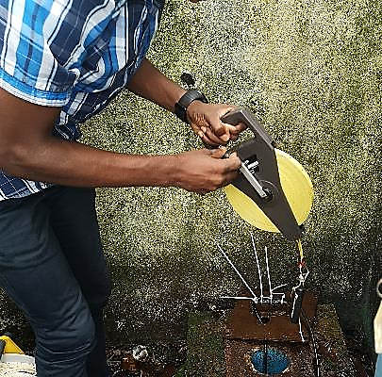

The standard text for your fundraising page or emails to spread the word amongst your networks

[Insert *team/individual/company* name here] is taking part in the Walking for Water campaign to raise vital funds to support Groundwater Relief’s Big Give Challenge. Your support will enable Groundwater Relief to develop our groundwater measuring tool called the Pocket Dipper to enable groundwater monitoring and management in water-stressed regions around the world.

We will be walking 100,000 steps between Tuesday 29th November and Tuesday 6th December. To gain double donations, we must receive your sponsorship during this week and it can be deposited on our fundraising page [*Insert your own fundraising sponsorship page*] or on the Groundwater Relief Big Give Campaign page [here.](https://donate.thebiggive.org.uk/campaign/a056900002NhhLHAAZ)

**Groundwater Relief & the Pocket Dipper**

[Groundwater Relief](http://www.groundwater-relief.org) is a UK-registered charity providing groundwater expertise and services to organisations and government agencies responsible for water provision. Groundwater Relief help to develop and manage safe and sustainable sources of water and offer capacity building to ensure vulnerable communities can confidently become custodians of their water resources. They achieve this by working with our global technical membership of over 450 people from 56 different countries ensuring they engage the highest level of expertise to deliver the best results.  
  
[The Pocket Dipper](https://groundwater-relief.org/support-us) is a simple, low cost, light weight, portable tool designed to measure groundwater levels. It is a tool that could be used by everyone, from a local citizen with no training in groundwater monitoring to an experienced water technician or hydrogeologist. This tool will help communities to record and better understand their groundwater resources.

**What is the Christmas Challenge?**  
[The Christmas Challenge](https://www.thebiggive.org.uk/christmas-challenge/) (the UK’s biggest online match funding campaign) helps UK-registered charities to raise funds for their projects by doubling donations when the campaign goes live on November 29th 2022.